**Change Request #3 Log: (Horizontal and Vertical Scroll Bars of jEdit)**

**Team 18: Teena Thomas, Nazeera Siddiqui, and John Scalley**

|  |  |
| --- | --- |
| **Scripter** | **Coder** |
| Teena Thomas | Nazeera Siddiqui |

**Table of Contents**

[**3.Concept Location 3**](https://docs.google.com/document/d/1WrywWwKnoXxqq0uy4LkPonQ175sszAq6nvi-5SQ4r9w/edit#heading=h.vh7fktschen)

[**4.Impact Analysis 5**](https://docs.google.com/document/d/1WrywWwKnoXxqq0uy4LkPonQ175sszAq6nvi-5SQ4r9w/edit#heading=h.719okbsq8xy4)

[**5.Prefactoring (optional) 6**](https://docs.google.com/document/d/1WrywWwKnoXxqq0uy4LkPonQ175sszAq6nvi-5SQ4r9w/edit#heading=h.5r4aa1ukdfoq)

[**6.Actualization 7**](https://docs.google.com/document/d/1WrywWwKnoXxqq0uy4LkPonQ175sszAq6nvi-5SQ4r9w/edit#heading=h.wc143g6623cg)

[**7.Postfactoring (optional) 8**](https://docs.google.com/document/d/1WrywWwKnoXxqq0uy4LkPonQ175sszAq6nvi-5SQ4r9w/edit#heading=h.2b51yt4xp4uo)

[**8.Validation 9**](https://docs.google.com/document/d/1WrywWwKnoXxqq0uy4LkPonQ175sszAq6nvi-5SQ4r9w/edit#heading=h.4unyr72up8v)

[**9.Timing 10**](https://docs.google.com/document/d/1WrywWwKnoXxqq0uy4LkPonQ175sszAq6nvi-5SQ4r9w/edit#heading=h.jpcorhpau452)

[**10.Reverse engineering 11**](https://docs.google.com/document/d/1WrywWwKnoXxqq0uy4LkPonQ175sszAq6nvi-5SQ4r9w/edit#heading=h.7xo7vl2js1gc)

[**UML Sequence Diagram 11**](https://docs.google.com/document/d/1WrywWwKnoXxqq0uy4LkPonQ175sszAq6nvi-5SQ4r9w/edit#heading=h.aog91px8iyz2)

[**UML Class Diagram** 12](https://docs.google.com/document/d/1WrywWwKnoXxqq0uy4LkPonQ175sszAq6nvi-5SQ4r9w/edit#heading=h.5ktphtqkefbj)

[**11.Conclusions 13**](https://docs.google.com/document/d/1WrywWwKnoXxqq0uy4LkPonQ175sszAq6nvi-5SQ4r9w/edit#heading=h.t07o7n5kx6vw)

[**Reference 14**](https://docs.google.com/document/d/1WrywWwKnoXxqq0uy4LkPonQ175sszAq6nvi-5SQ4r9w/edit#heading=h.rwe9eknz4feu)

3.Concept Location

Use the table below to describe each step you follow when performing concept location for this change request. In your description, include the following information when appropriate:

* IDE Features used (e.g., searching tool, dependency navigator, debugging, etc.)
* Queries used when searching
* System executions and input to the system
* Interactions with the system (e.g., pages visited)
* Classes visited
* The first class found to be changed (this is when concept location ends)

When there is a major decision/step in the process, include its rationale, i.e., why that decision/step was taken.Make sure you time yourselves when going through this process and provide the total time spent below.The following is an example of a concept location process for the change request "Color student schedule":

|  |  |  |
| --- | --- | --- |
| **Step #** | **Description** | **Rationale** |
| **1** | *Look at files in org.gjt.sp.jedit.gui folder* | *We want to find the menu bar because we need to add the option to show/hide the scroll bars.* |
| **2** | *Opened PanelWindowContainer..java* | *We were not sure what this class contained so we opened PanelWindowContainer.java to determine if it was relevant.* |
| **3** | *Look at files in org.gjt.sp.jedit.textarea folder* | *The  files in org.gjt.sp.jedit.gui folder did not contain what we were looking for and org.gjt.sp.jedit.textarea folder may contain code  pertained those in change request.* |
| **4** | *Opened ScrollLayout.java* | *Naming convention matched the change request* |
| **5** | *Opened ScrollListener.java* | *Naming convention matched the change request* |
| **6** | *Opened TextArea.java* | *This file seemed like it is associated with the scrollbar mentioned in the change request* |
| **7** | *Opened ScrollLineCount.java* | *This file seemed like it may be associated with the scrollbar mentioned in the change request* |
| **8** | *Look at files in org.gjt.sp.jedit.menu folder* | *The  files in org.gjt.sp.jedit.menu folder may contain code  pertained those in change request.* |
| **9** | *Opened EnhancedMenu.java* | *This file seemed like it may be associated with the scrollbar mentioned in the change request* |
| **10** | *Re-opened TextArea.java* | *This file seemed like it is more associated with the scrollbar mentioned in the change request* |
| **11** | *We ran the system* | *To determine where to add the new functionality of showing/hiding the scrollbars and find other similar features.* |
| **12** | *We interacted with the system* | *To get familiar with the overall behavior of the scrollbars apparent  in the system.* |
| **13** | *Look at files in org.gjt.sp.jedit  folder* | *The  files in org.gjt.sp.jedit folder may contain code pertained those in change request.* |
| **14** | *Opened View.java* | *This file seemed like it is associated with the View menu mentioned in the change request* |
| **15** | *We focused in on the updateBufferSwitcherStates function.* | *This was associated with the View menu so we wanted to observe the overall behavior/structure of the function.* |
| **16** | *We also focused in on the ScrollHandler class.* | *This is because it seemed to pertain to the change request.* |
| **17** | *Read comments at the beginning of View.java* | *To understand what is contained in View.* |
| **18** | *Searched for xml files using WindowsExplorer* | *To try to find something for the menus in jEdit as we could not find it in the other files we looked at.* |
| **19** | *Opened actions.xml* | *It seemed to be relevant to this change request.* |
| **20** | *Opened ActionSet.java* | *After looking at actions.xml, we know we need to add a new action and this class seemed relevant.* |
| **21** | *Opened jEdit.java* | *jEdit contains main* |
| **22** | *Opened PropertyManager.java* | *We focused on initSystemProperties() in jEdit which initialized  jEdit’s properties.* |
| **23** | *Looked up documentation for java.util.Properties* | *To load the properties for jEdit, loadSystemProps() called loadProps() in PropertyManager. Then loadProps called load() which is a function from the Properties class* |
| **24** | *Opened jedit_gui.props* | *This file is loaded* |
| **25** | *Opened jedit_en.props* | *This file is also loaded* |
| **26** | *Opened jedit.props* | *This is also loaded* |
| **27** | *Opened GutterOptionPane.java* | *The view menu has the option to toggle the gutter. To see how this is implemented for gutter and get a better idea how to implement this new functionality for the scroll bars.* |
| **28** | *Opened AbstractOptionPane.java* | *GutterOptionPane.java inherits from this class* |

**Time spent (in minutes):** 427

4.Impact Analysis

Use the table below to describe each step you follow when performing impact analysis for this change request. Include as many details as possible, including why classes are visited or why they are discarded from the estimated impact set.

Do not take the impact analysis of your changes lightly. Remember that any small change in the code could lead to large changes in the behavior of the system. Follow the impact analysis process covered in the class. Describe in detail how you followed this process in the change request log. Provide details on how and why you finished the impact analysis process.

|  |  |  |
| --- | --- | --- |
| **Step #** | **Description** | **Rationale** |
| **1** | *Changes only need to be made to the .props (jedit_gui, jedit, jedit_en) files as we they contain the system properties and TextArea.java and actions.xml* | *Changes in the properties files were to make a new menu item and add a checkbox to toggle the scrollbars. We also added getters for the boxes containing the vertical and horizontal scroll bars as they are private members in TextArea so that actions.xml can hide the scroll bars.* |
| **2** | *View.java class is eliminated for this change request* | *We made the change in actions.xml* |

**Time spent (in minutes):** 60

5.Prefactoring (optional)

Using the table below, describe each step you follow to prefactor the code. Include as many details as possible, including the refactoring operations used (e.g., move method, extract class, etc.) and classes/methods/fields that were modified, added, removed, renamed, etc.

|  |  |  |
| --- | --- | --- |
| **Step #** | **Description** | **Rationale** |
| **1** | *Added comments on method to be changed* | *Aid in maintenance and track our changes* |
| **2** | *Removed comments on method to be changed* | *The comments were serving as a personal aid.* |
| **3** | *We committed our changes with git.* | *Just in case we need to revert our changes.* |
| **4** | *...* |  |

**Time spent (in minutes):** 25

6.Actualization

Use the table below to describe each step you followed when changing the code. Include as many details as possible, including why classes/methods were modified, added, removed, renamed, etc.

|  |  |  |
| --- | --- | --- |
| **Step #** | **Description** | **Rationale** |
| **1** | *Added a new item in jedit_gui.props* | *A new item needs to be added to the view menu to toggle the scroll bars. jedit_gui.props contains jEdit’s gui properties.* |
| **2** | *Added a boolean property in jedit.props* | *A boolean property to determine if the scroll bars are being shown or hidden is needed.* |
| **3** | *Added a label for the new item in the view menu in jedit_en.props* | *A new menu item was created in jedit_gui.props and we need to create the label in jedit_en.props* |
| **4** | *Added a new action to actions.xml* | *actions.xml contains jEdit’s action table for keystrokes and menu item selections. We needed a new action for toggling the scroll bars.* |
| **5** | *Added a new variable in TextArea.java. A new Box variable called horizontalBox was created for the horizontal scroll bar.* | *Although a Box component verticalBox which contains the vertical scroll bar is already created, there is no box for the horizontal scroll bar.* |
| **6** | *Add two new getter functions in TextArea.java* | *verticalBox and horizontalBox are private attributes for the TextArea class. Therefore, we need to add two getter functions so we can change the visibility of the vertical and horizontal scroll bars.* |

**Time spent (in minutes):** 120

7.Postfactoring (optional)

Use the table below to describe each step you followed to postfactor the code. Include as many details as possible, including the refactoring operations used (e.g., move method, extract class, etc.) and classes/methods/fields that were modified, added, removed, renamed, etc.

|  |  |  |
| --- | --- | --- |
| **Step #** | **Description** | **Rationale** |
| **1** |  |  |
| **2** |  |  |
| **3** |  |  |

**Time spent (in minutes): 0**

8.Validation

Use the table below to describe any validation activity (e.g., testing, code inspections, etc.) you performed for this change request. Include the description of each test case, the result (pass/fail) and its rationale.

|  |  |  |
| --- | --- | --- |
| **Step #** | **Description** | **Rationale** |
| **1** | ***Test case defined:*** *Open a document that exceeds the size of the editor, on jEdit.*  ***Inputs:*** *A document that exceeds the size of the editor*  ***Expected output:*** *jEdit displays the horizontal and vertical scroll bars. An option is present on the View menu which allows to hide the scrollbars.* | *This is the regular expected behavior.*  *The test passed.*  *Did not change old behavior but added a new feature.* |
| **2** | ***Test case defined:*** *Open a document that does not exceeds the size of the editor, on jEdit.*  ***Inputs:*** *A document that does not exceeds the size of the editor*  ***Expected output:*** *jEdit does not display the horizontal and vertical scroll bars* | *This is the regular expected behavior.*  *The test passed.*  *Did not change old behavior* |
| **3** | ***Test case defined:*** *Open a document that exceeds the size of the editor, on jEdit and hide the scrollbars bymeans of the hide scrollbar feature, found in the View menu.*  ***Inputs:****A document that exceeds the size of the editor.*  ***Expected output:*** *jEdit does not displays the horizontal and vertical scroll bars.* | *This is the expected behavior.*  *The test passed.*  *Changes were made to old behavior* |
| **4** | ***Test case defined:*** *Open a document that does not exceeds the size of the editor, on jEdit and hide the scrollbars bymeans of the hide scrollbar feature, found in the View menu.*  ***Inputs:****A document that does not exceeds the size of the editor.*  ***Expected output:*** *jEdit does not displays the horizontal and vertical scroll bars.* | *This is the expected behavior.*  *The test passed.*  *Both the old behavior and added new feature are working in compliance* |

**Time spent (in minutes): 35**

9.Timing

Summarize the time spent on each phase.

|  |  |
| --- | --- |
| **Phase Name** | **Time (in minutes)** |
| Concept location | 427 |
| Impact Analysis | 60 |
| Prefactoring | 25 |
| Actualization | 120 |
| Postfactoring | 0 |
| Verification (Validation) | 35 |
| **Total** | **667** |

10.Reverse engineering

UML Sequence Diagram

Create a **UML sequence diagram** (or more if needed) corresponding to the main object interactions affected by your change.

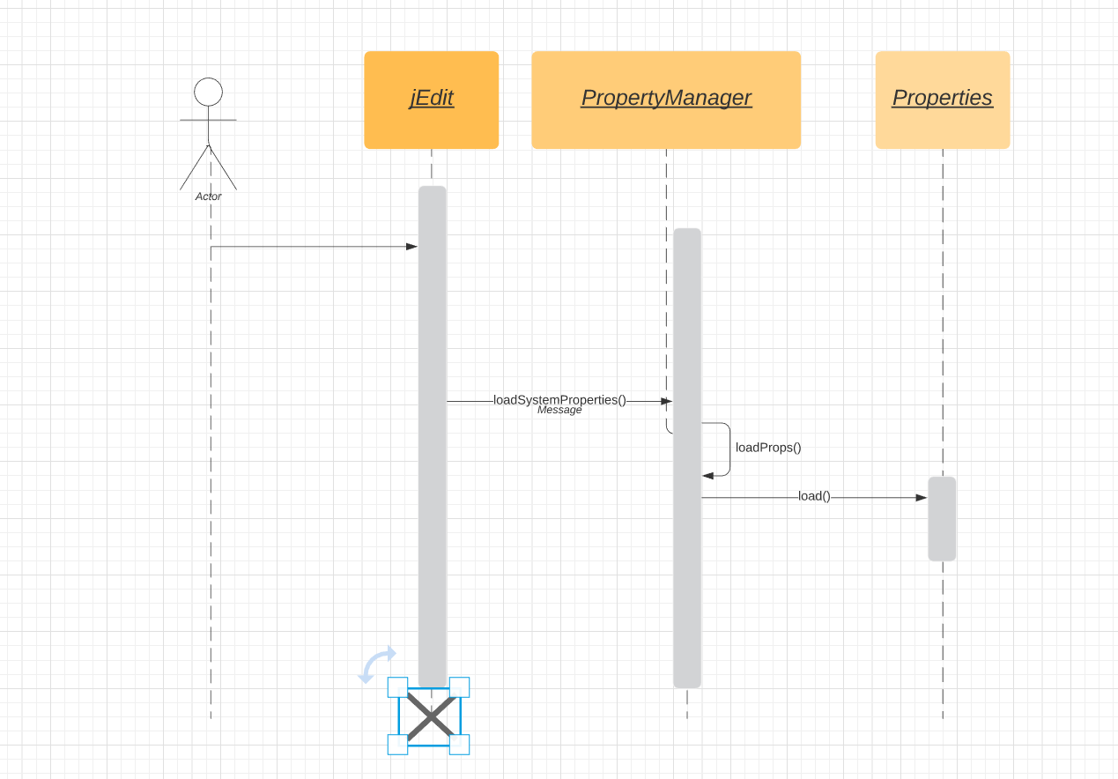

UML Class Diagram

Create a partial **UML class diagram** of the classes visited while navigating through the code. Include the associations between classes (e.g., inheritance, aggregations, compositions, etc.), as well as the important fields and methods of each class that you learn about. The diagram may have disconnected components. Use the UML tool of your preference. When a significant fact about a class or method is learned, indicate it via annotations on the diagram. For each change request, start with the diagram produced in the previous change request. **For the first, you will start from scratch.**

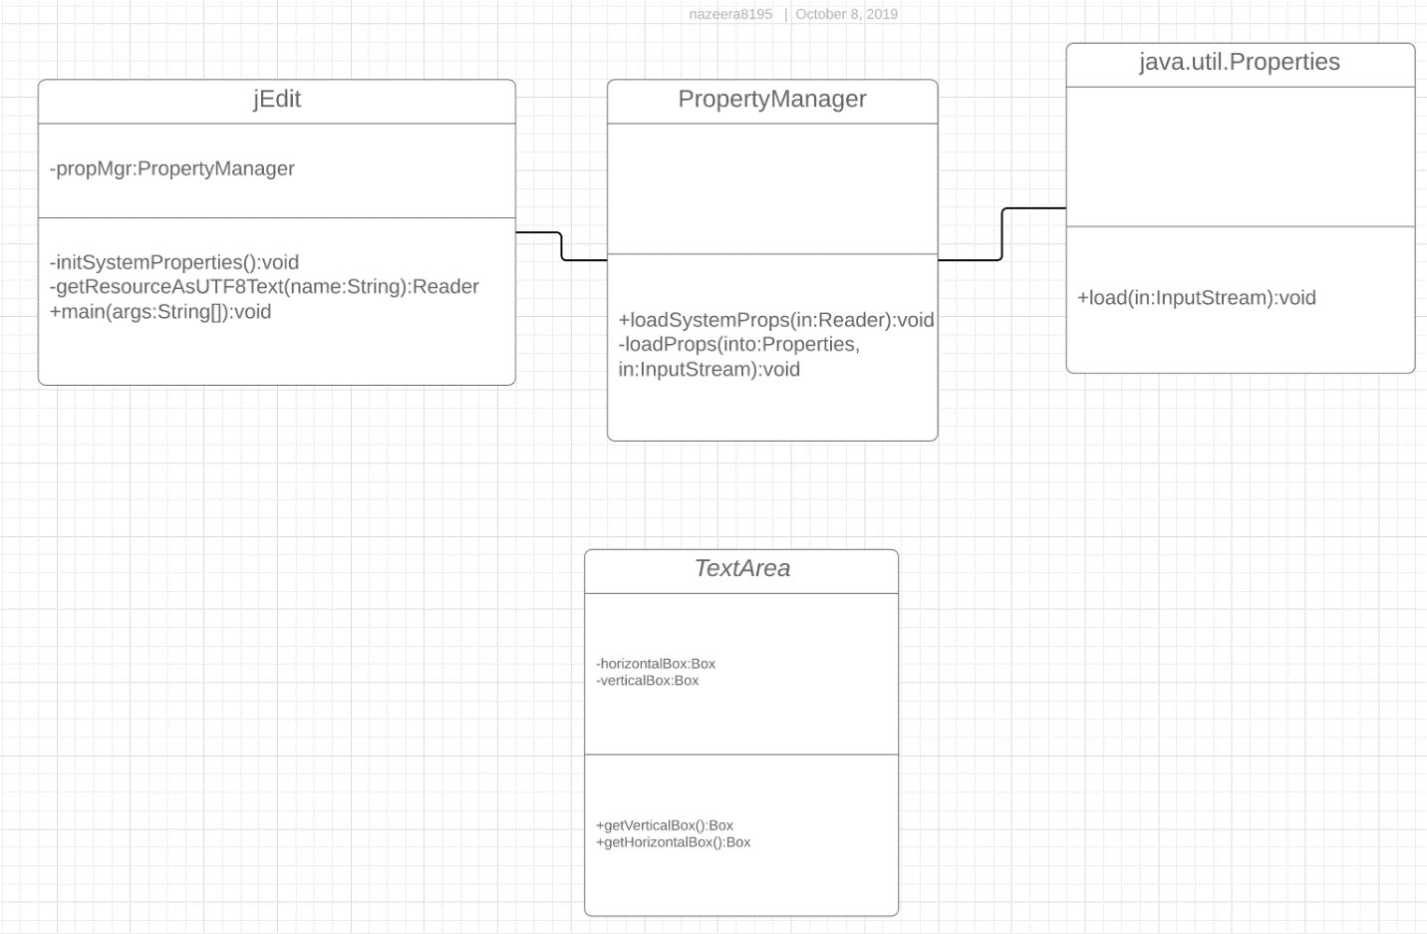

11.Conclusions

Perform and analysis of the change requests and the change process.  List the major challenges this change request posed.

The biggest problem we faced was in trying to locate where to make the change. In hindsight, it would have been simpler to start from main in jEdit.java. There were many files and navigating through them was a bit challenging. Once the location of the change was found the actual implementation also took a bit of time as we had to think a proper logic to make our horizontal and vertical scrollbars hide using the View menu. Concept location, impact analysis, actualization (and change propagation) was done manually. Testing could not be performed using JUnit and Abbot.

**List all the classes and methods you have changed.**

Jedit_gui.props

Jedit.props

Jedit_en.props

In TextArea.java, getHorizontalBox() and getVerticalBox() functions were added.

Code was also added to actions.xml

**actions.xml:**

**<ACTION NAME="toggle-scrollbars">**

**<CODE>**

**boolean showing = jEdit.getBooleanProperty("view.showScrollBars");**

**jEdit.setBooleanProperty("view.showScrollBars", !showing);**

**textArea.getVerticalBox().setVisible(!showing);**

**textArea.getHorizontalBox().setVisible(!showing);**

**jEdit.propertiesChanged();**

**</CODE>**

**<IS_SELECTED>**

**return jEdit.getBooleanProperty("view.showScrollBars");**

**</IS_SELECTED>**

**</ACTION>**

**Changes made to TextArea.java :**

**private final Box verticalBox;**

**private final Box horizontalBox;**

**public final Box getVerticalBox(){**

**return verticalBox;**

**}**

**public final Box getHorizontalBox(){**

**return horizontalBox;**

**}**

Reference

“UML 2 Class Diagrams: An Agile Introduction.” *UML 2 Class Diagrams: An Agile Introduction*, Agile Modeling, agilemodeling.com/artifacts/classDiagram.htm.

“Unified Modeling Language (UML): Sequence Diagrams.” *Unified Modeling Language (UML) | Sequence Diagrams*, GeeksforGeeks , 12 Feb. 2018, www.geeksforgeeks.org/unified-modeling-language-uml-sequence-diagrams/.